SCC Highways - Advanced Warning Signs (July 26)

Scheme –
Location | The Mount, Guildford |  |  |  |  | Borough | GUI
Permit Ref: | MA900CP26-656458-BTS-03 |  |  |  |  | Date | 01/09/26
Signs | 2 | Letters | 64 | Officer | JoH | Comms Audit
Cllr and other stakeholders | Angela Goodwin
Notes | Please place signs & deliver Letters to all residents and businesses.
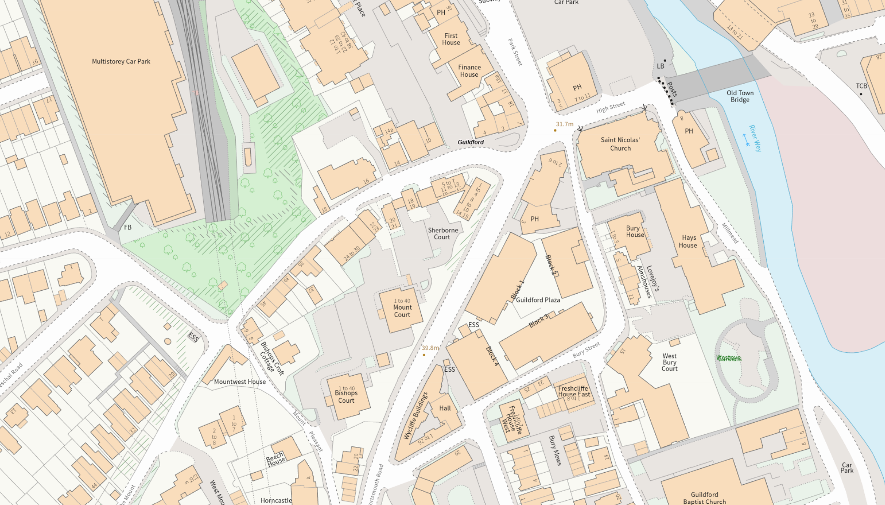
ROAD CLOSED

14 September
For 4 Days
8am – 5pm

NO PARKING

